LAB-3.4
Task 1: Zero-shot Prompt – Fibonacci Series Generator
Task Description #1
• Without giving an example, write a single comment prompt
asking GitHub Copilot to generate a Python function to print the
first N Fibonacci numbers.
Prompt used: # generate a python program for the first n fibonacci numbers
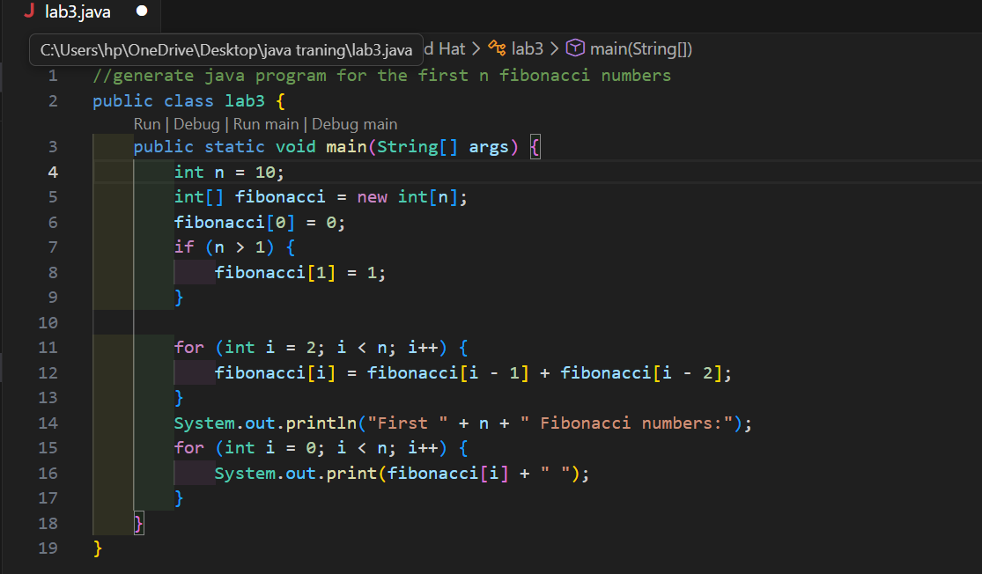
Sample output:
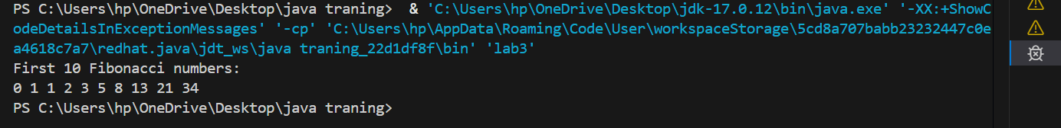

Task 2: One-shot Prompt – List Reversal Function
Task Description #2
• Write a comment prompt to reverse a list and provide one
example below the comment to guide Copilot.

Prompt used: # generate a python program to reverse a list using loop dynamically user input

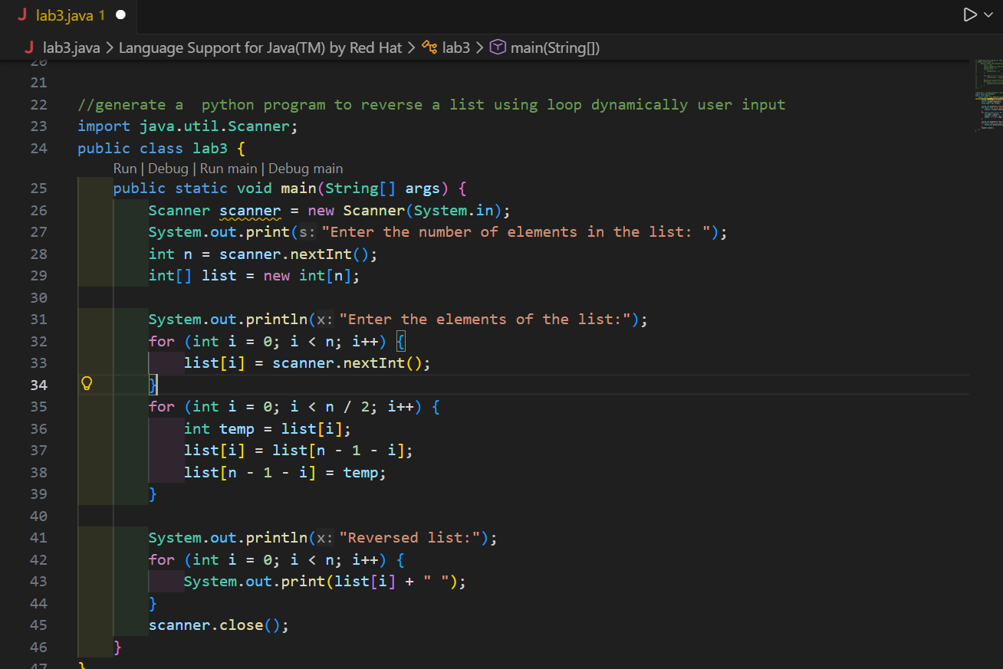
Sample output:
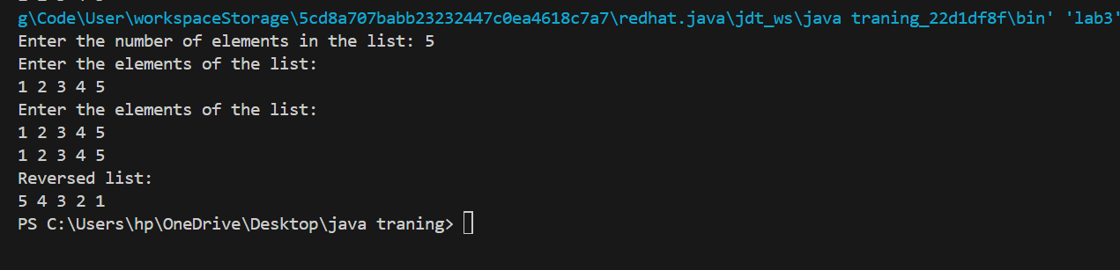

Task 3: Few-shot Prompt – String Pattern Matching
Task Description #3
• Write a comment with 2–3 examples to help Copilot understand
how to check if a string starts with a capital letter and ends with a
period.
Prompt used: generate a python program to check if a string starts with capital and ends with period output should be boolean type
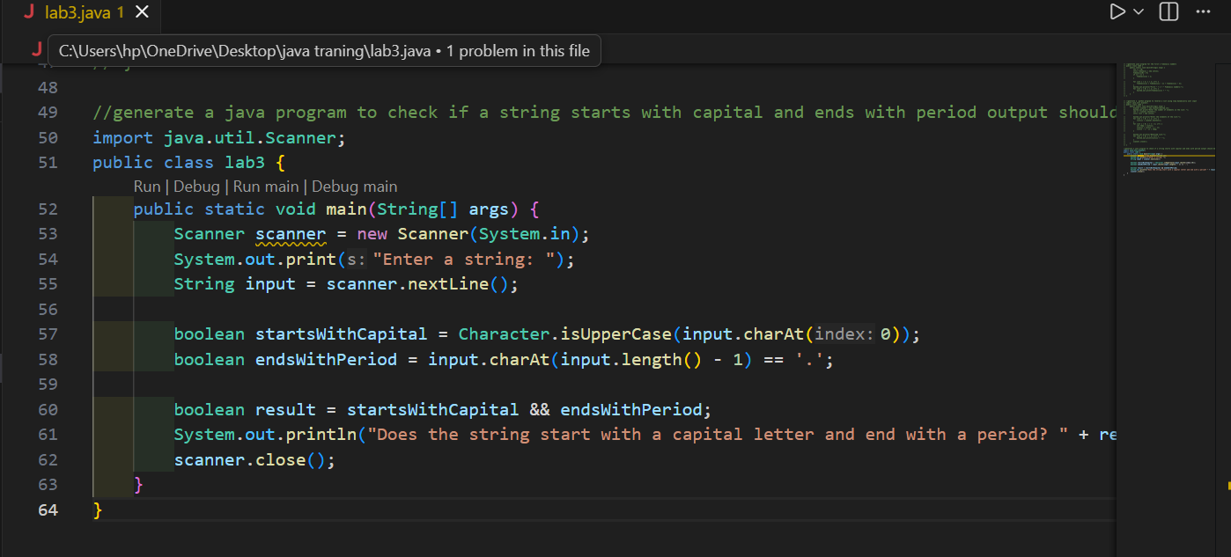
Sample output:
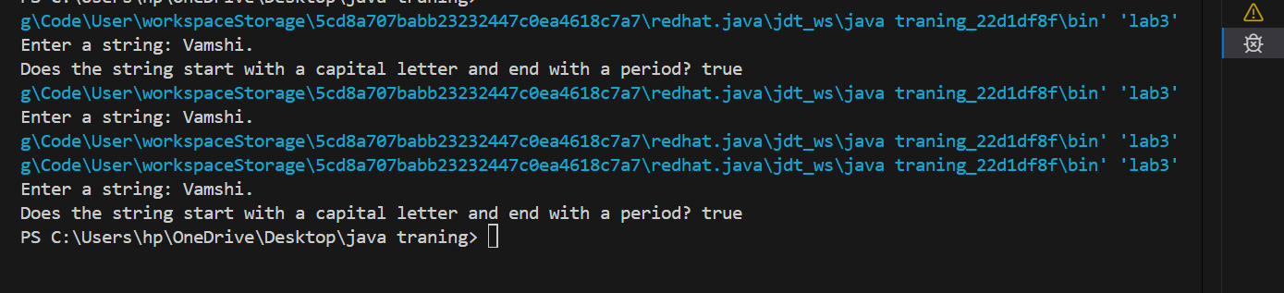

Task 4: Zero-shot vs Few-shot – Email Validator
Task Description #4
• First, prompt Copilot to write an email validation function using
zero-shot (just the task in comment).
• Then, rewrite the prompt using few-shot examples
Prompt used: # generate a python program to write an email validation function

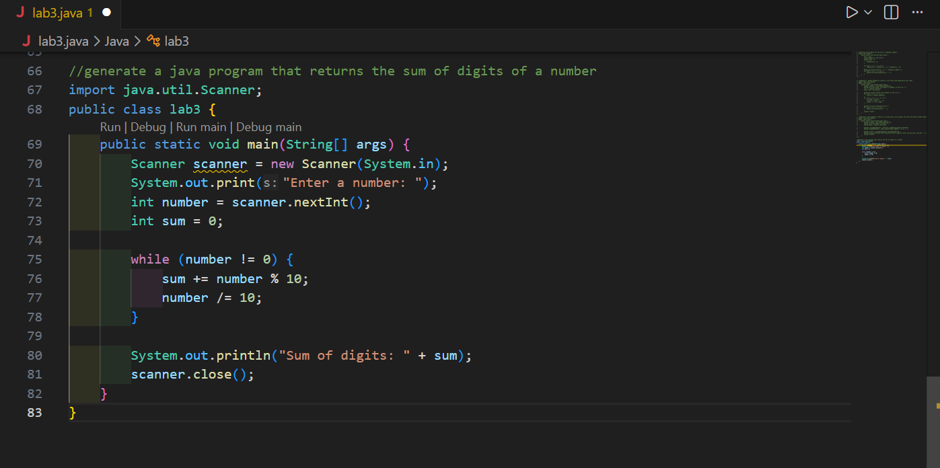
Sample output:
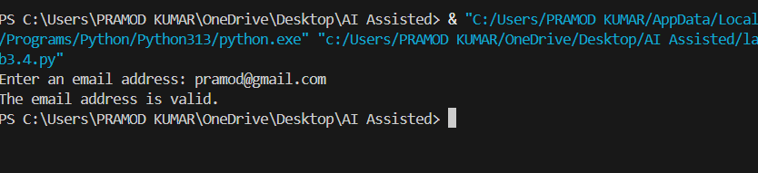

Task 5: Prompt Tuning – Summing Digits of a Number
Task Description #5
• Experiment with 2 different prompt styles to generate a function
that returns the sum of digits of a number.

Prompt used: generate a python program that returns the sum of digits of a number

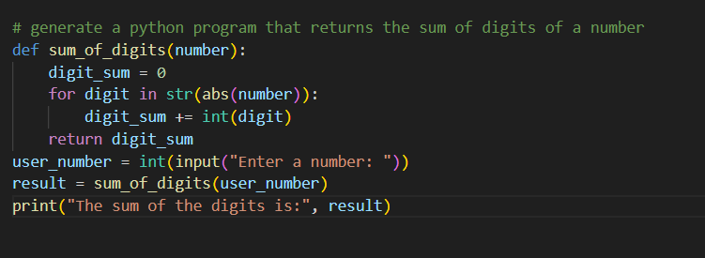
Sample output:
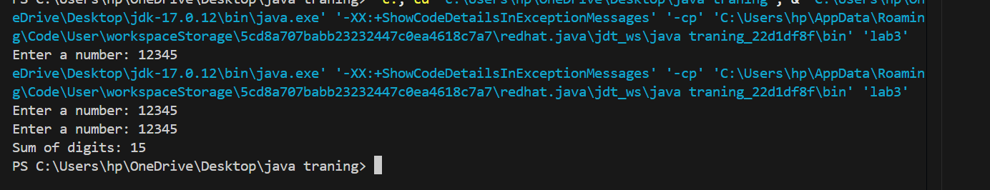

Scenario based:
# generate a python program that assists the cashier in generating customer bills.
# The program should accept the customers name, items purchased, and price of each item.
# It should calculate the total bill amount and apply discount based on higher discounts for higher bill amounts and lower discount for lower bill amounts.
# for example if the 1 kg of almond is 1200 but i need only 500 grams then the program should calculate the price accordingly.
# include the quantity in grams and price per kg to calculate the price for that item.
# include for example if the cost of the colgate is 120 but i need the 2 tubes then the program should calculate the price accordingly.
# it should also calculate the tax on discounted amount and display the final amount to be paid by the customer.
# the system should allow the cashier to generate the bills for multiple customers until they choose to exit the program.
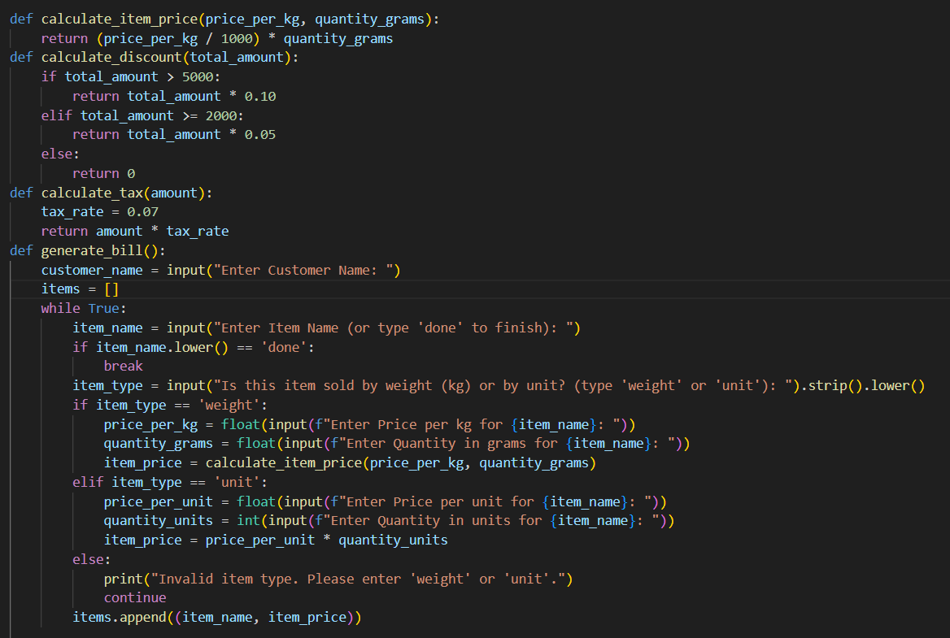
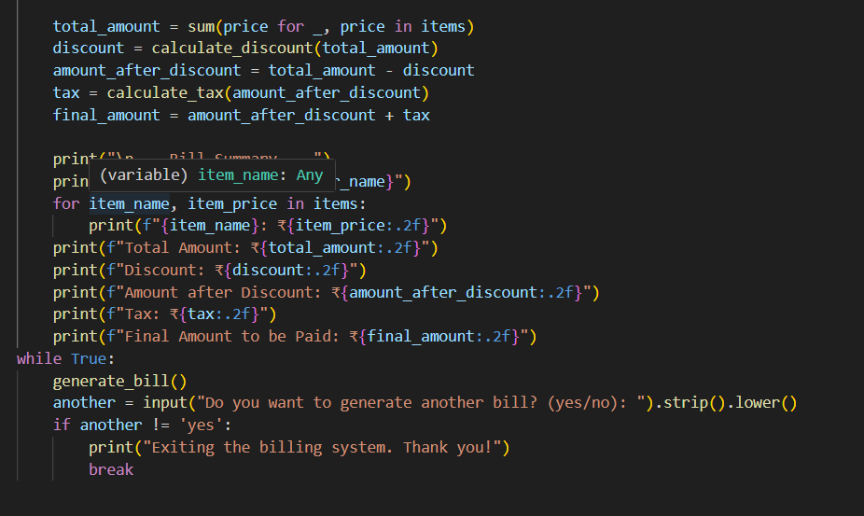

Sample output:
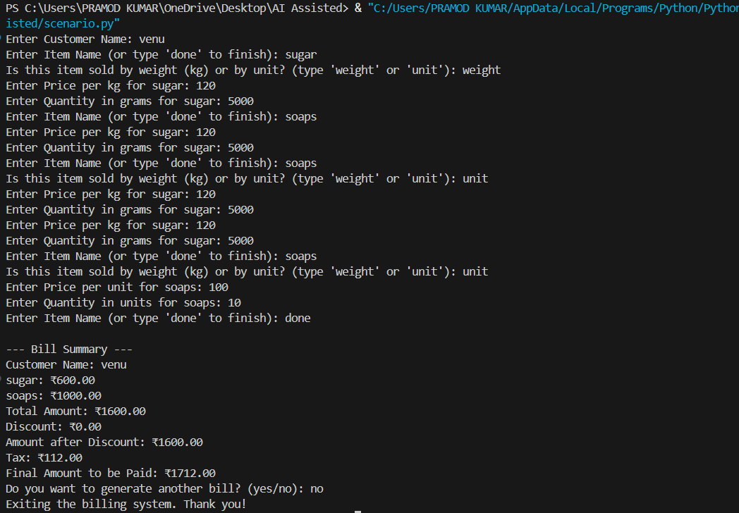

Explanation:
the program supports multiple customer transactions within a single session, allowing the cashier to generate and print itemized bills repeatedly until they choose to exit, making it a complete point-of-sale solution for small retailers.

